**Jenkins docker CICD project**

**reference:** [**https://github.com/sandeepdurai/java-web-app-docker.git**](https://github.com/sandeepdurai/java-web-app-docker.git)

**youtube:** [**https://youtu.be/hHZoV3LBIwE**](https://youtu.be/hHZoV3LBIwE)

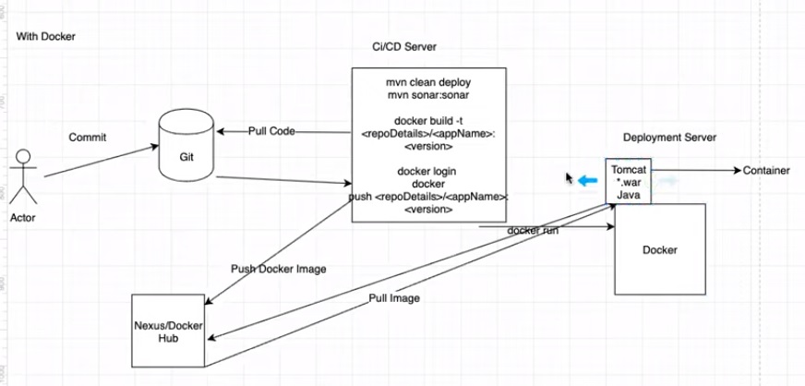

**step 1**

create two EC2 instance[ ubuntu]---> 1.jenkins java and dockers

2. only docker

==========================================================================

**install java and jenkins, docker: EC2-1**

* sudo apt install openjdk-8-jdk

* sudo wget -q -O - https://pkg.jenkins.io/debian/jenkins-ci.org.key | sudo apt-key add -

* sudo sh -c 'echo deb http://pkg.jenkins.io/debian-stable binary/ > /etc/apt/sources.list.d/jenkins.list'

* sudo apt update

* sudo apt install jenkins -y

* sudo systemctl status jenkins

* sudo apt install docker.io

# add jenkins user to docker

* sudo usermod -aG docker jenkins

*sudo systemctl restart Jenkins

**install docker in ec2-2:**

* sudo apt update

* sudo apt install docker.io

* sudo usermod -aG docker ubuntu

**Configer Jenkins**

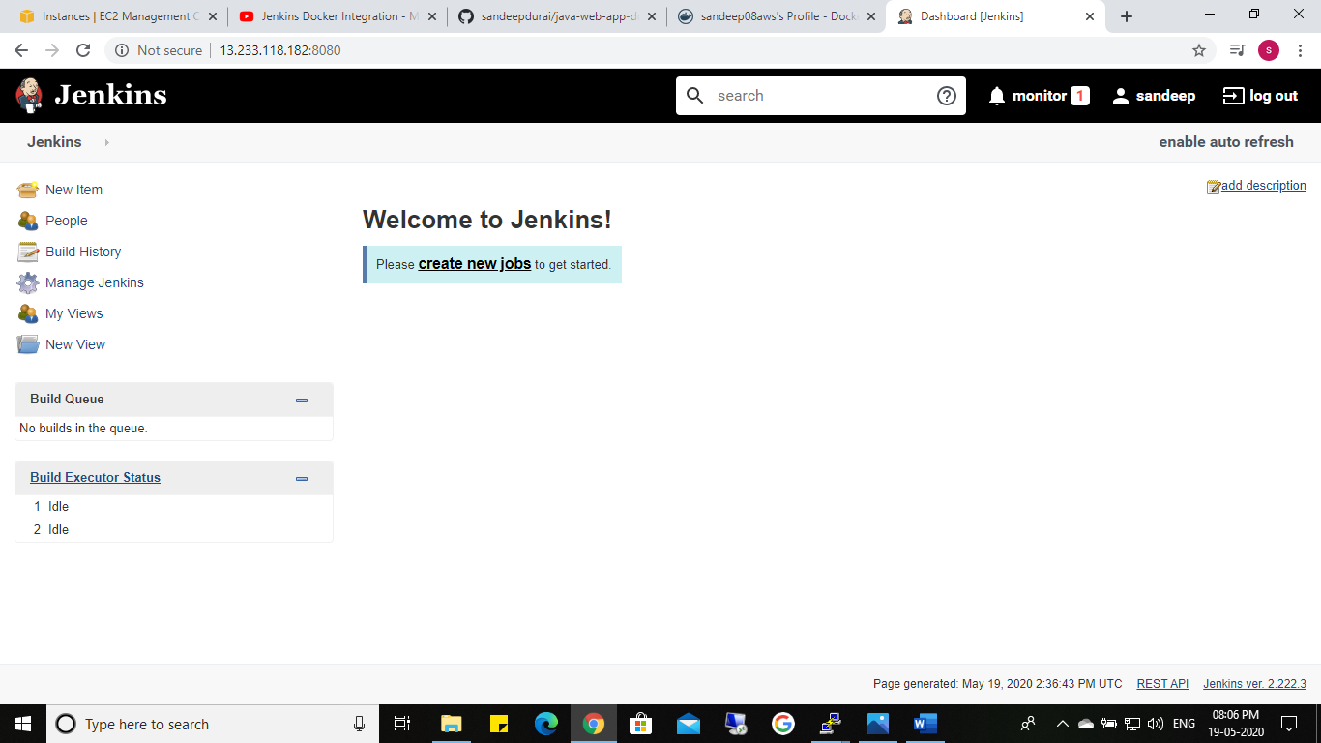

**Create job in jenkin:**

**Using pipeline**

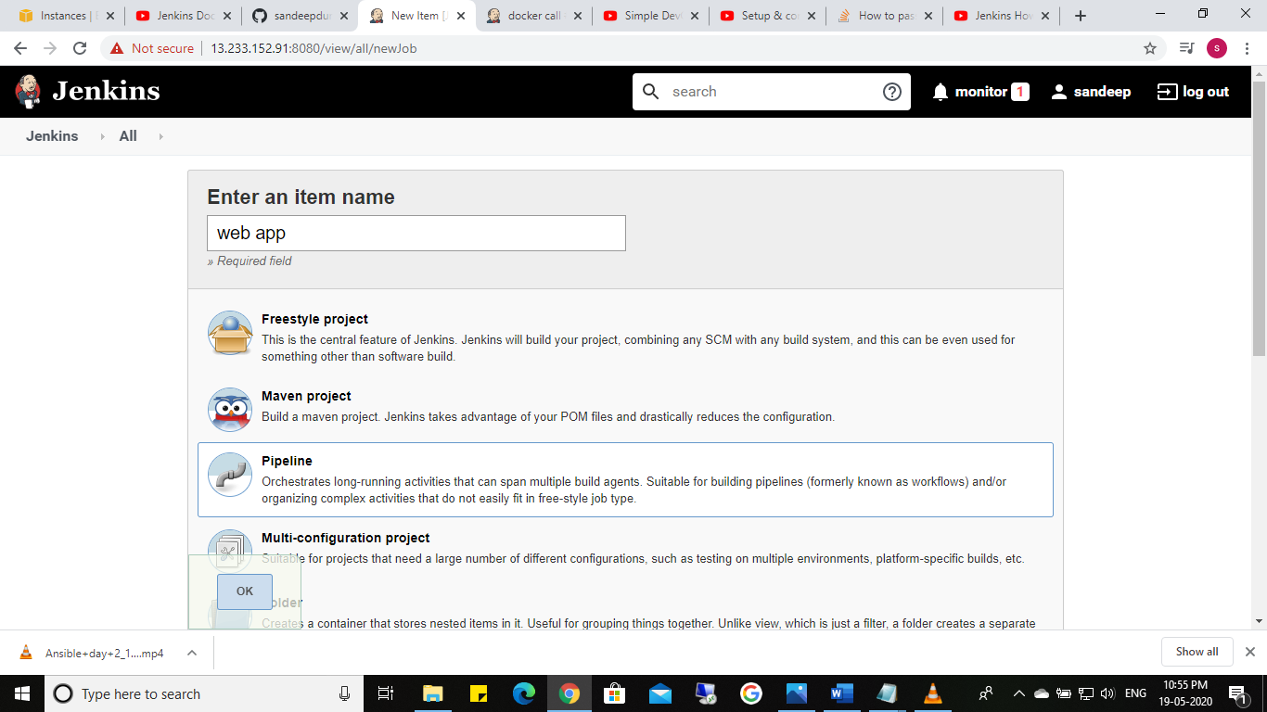

**Stage 1**

**Check the git repository**

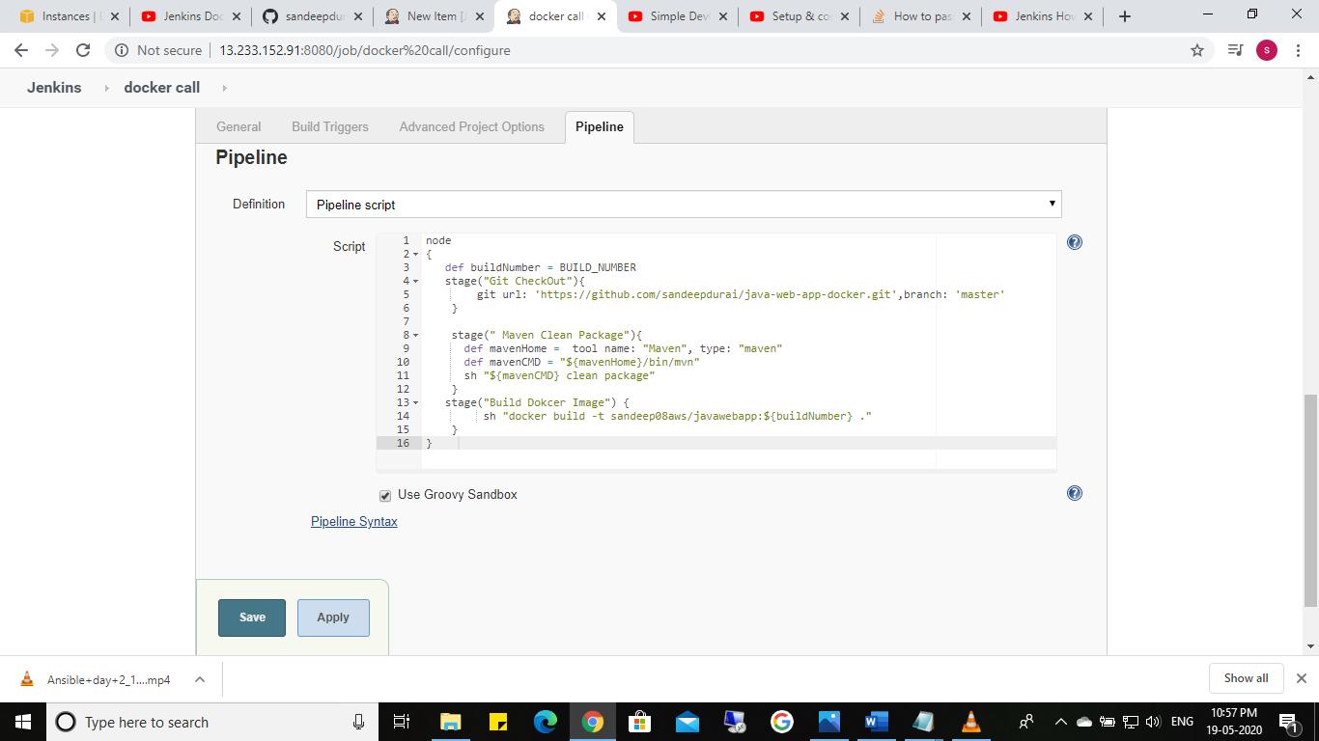

**Built – console output—success**

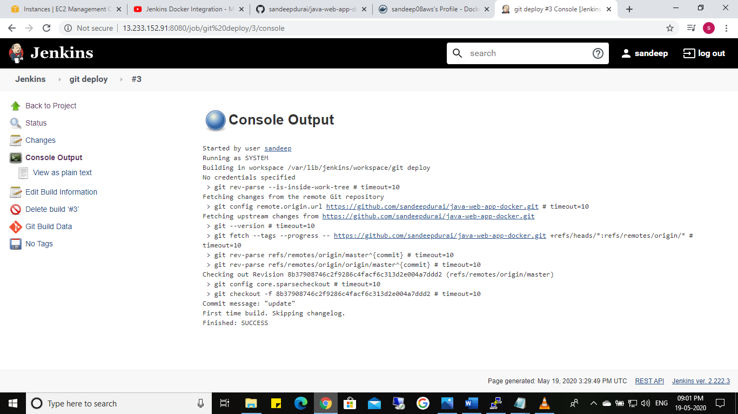

**Install maven**

**Stage 2**

**Install maven using global tool configuration**

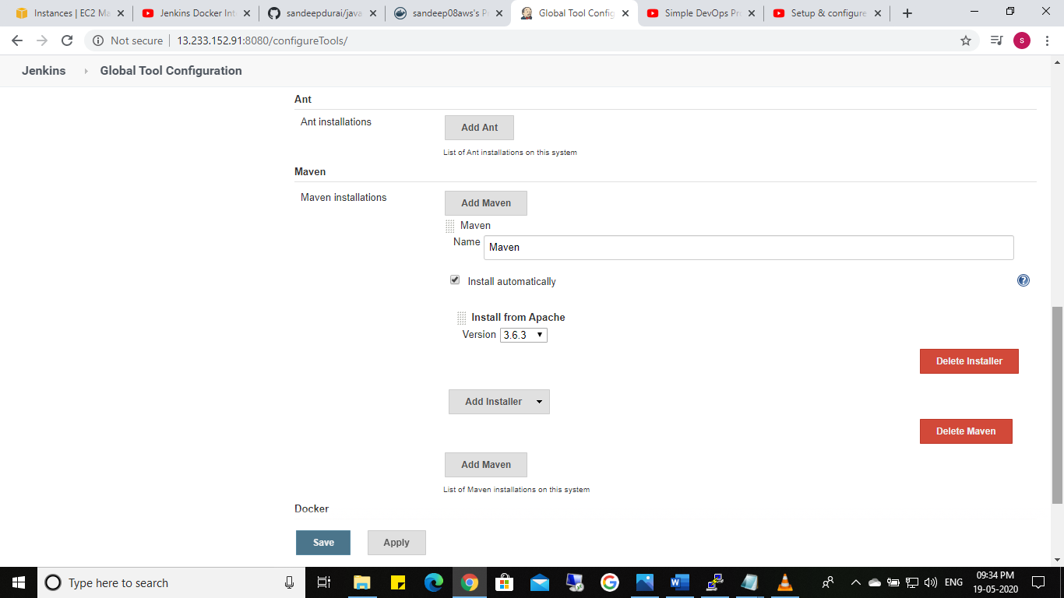

**Check using build stage 2**

**Stage 3**

**Create docker image using docker file in github : version as build number**

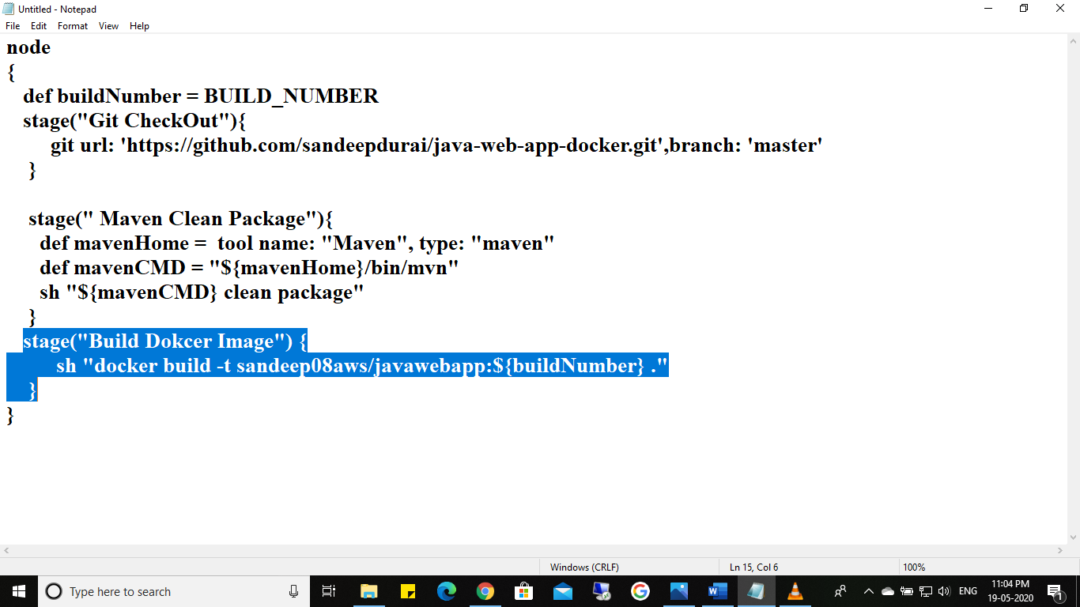

**Stage 4**

**For puch image to docker hub and log in :**

**Give credential as secret : using pipline sysntex**

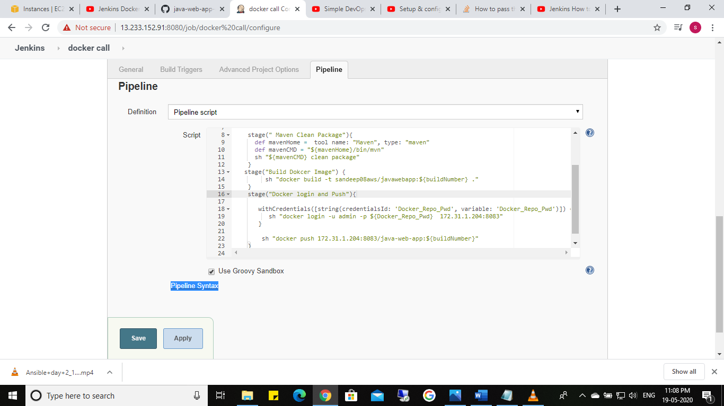

**With credential**

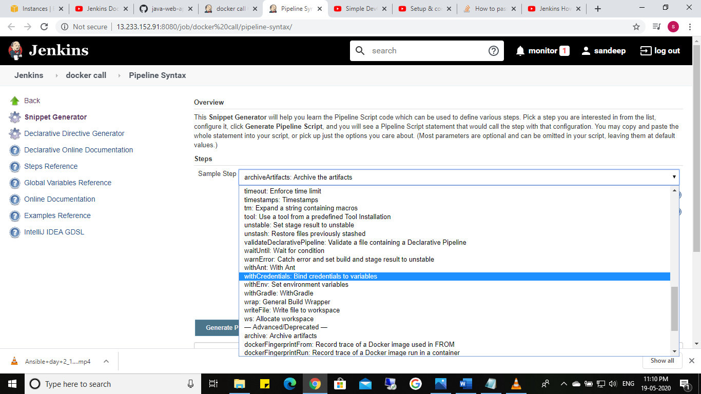

**Secret txt:**

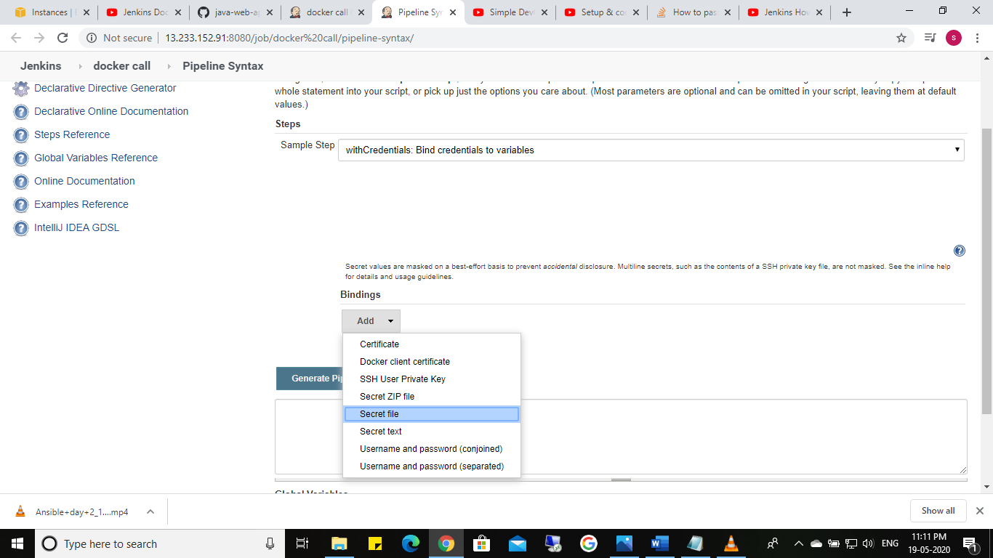

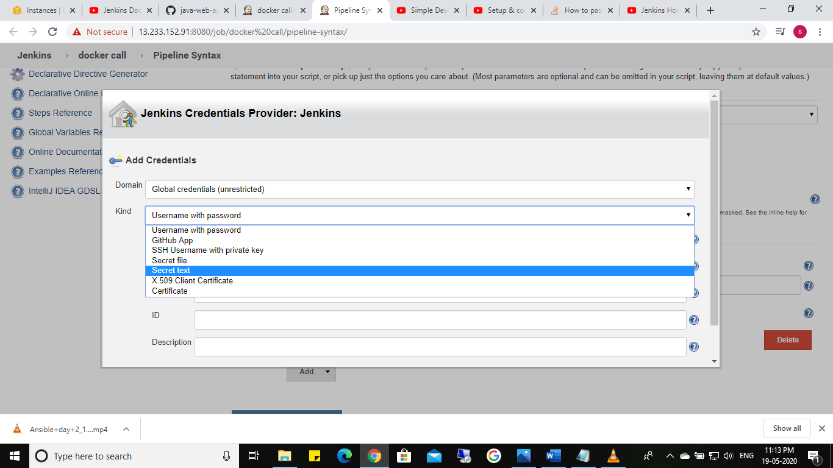

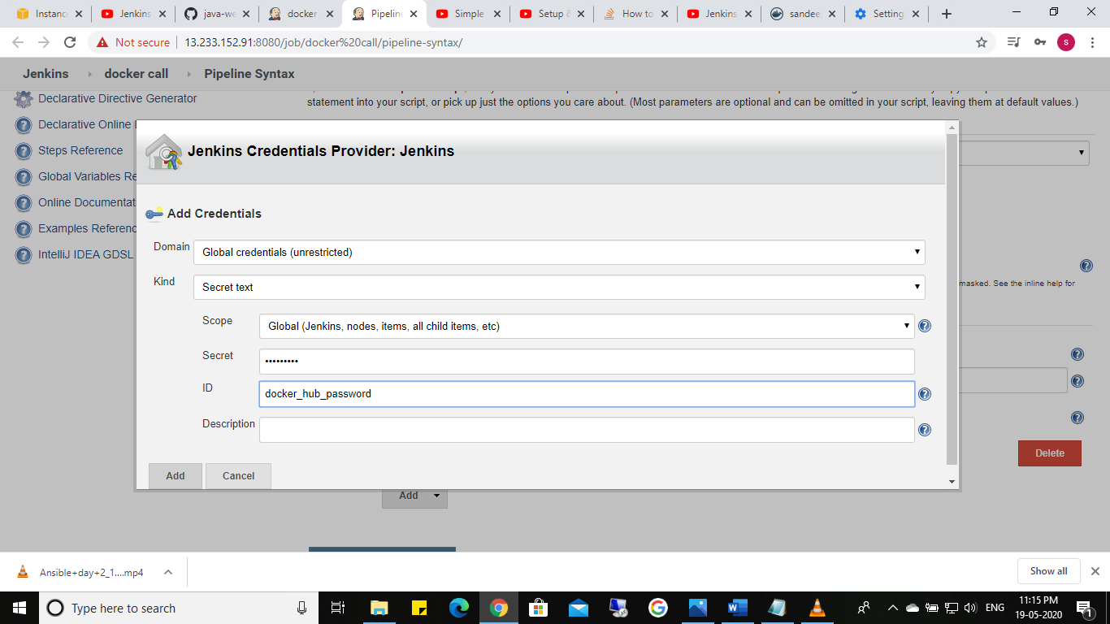

**Click generate pipeline script and copy the script**

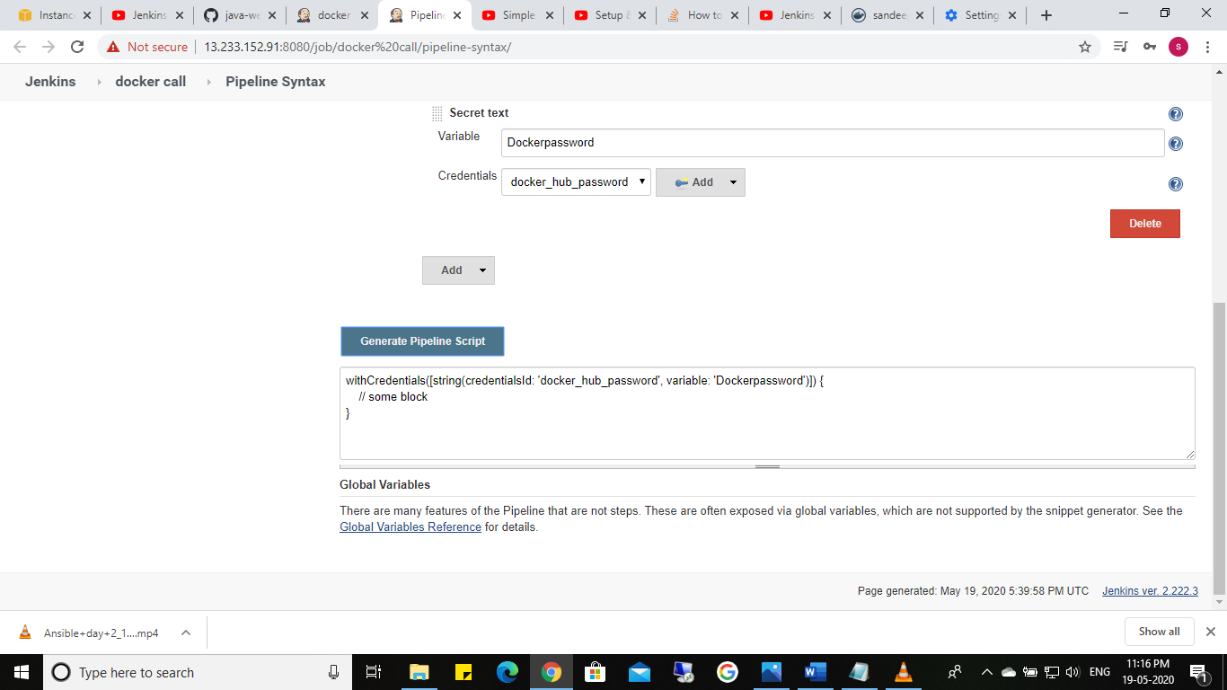

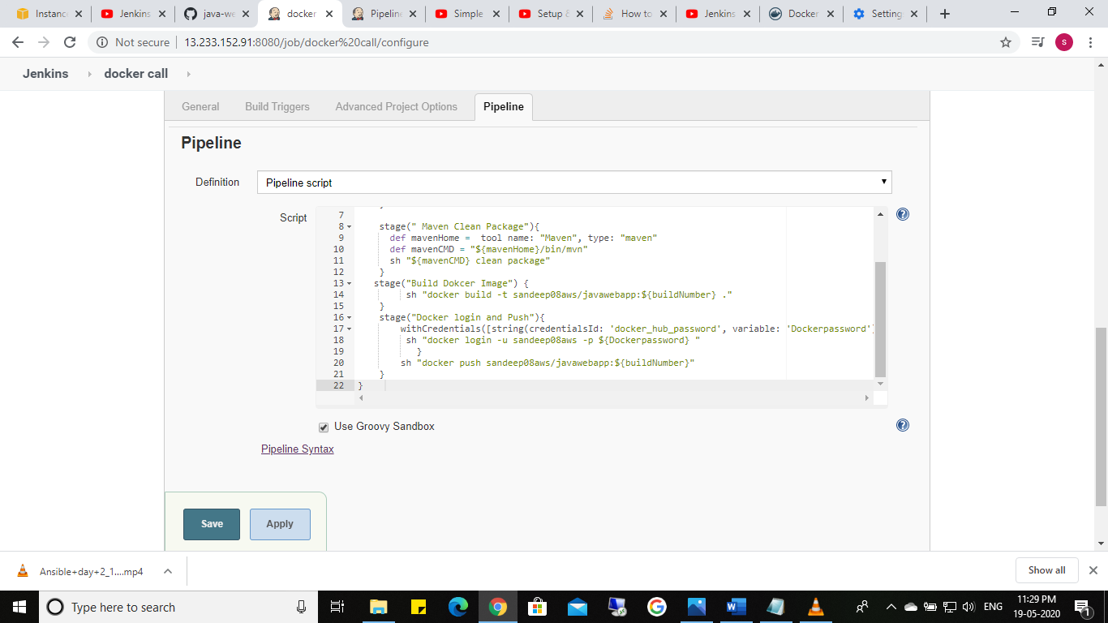

To check the stage 4 buld and check in docker hub:

Image in pushed to docker repository

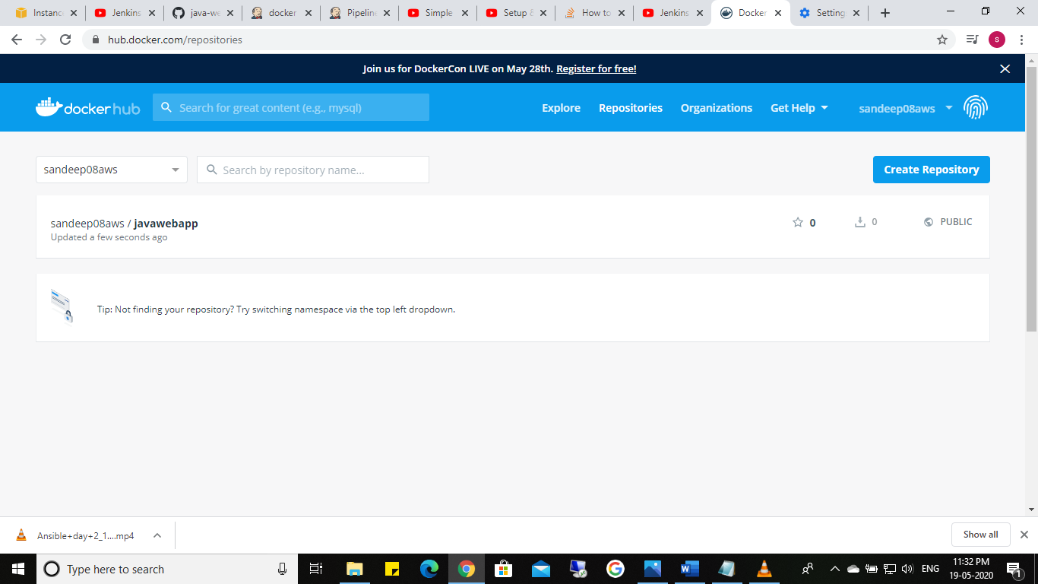

Stage 5

Deploy container to deployment server :

1. Install ssh user plugin : ssh agent

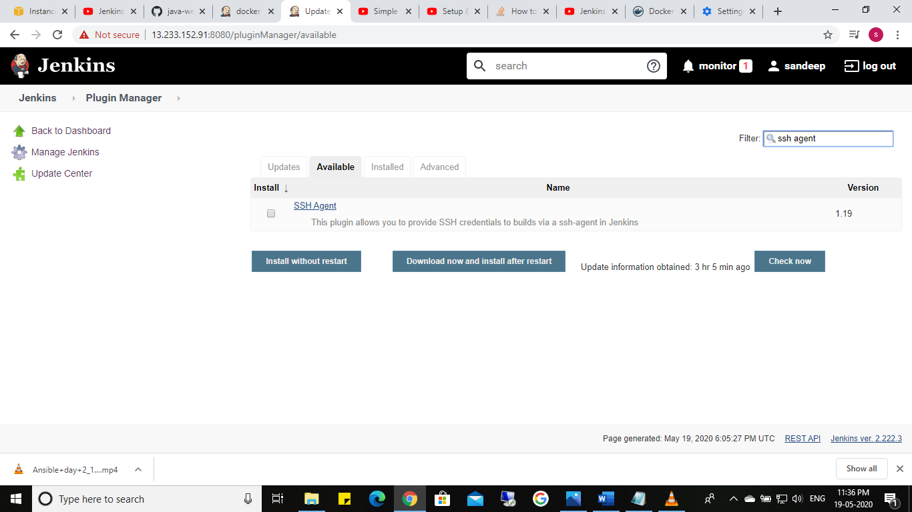

2.Connect Jenkins with docker deployer sever :

1. pipline syntex:



1. **Sshagent**

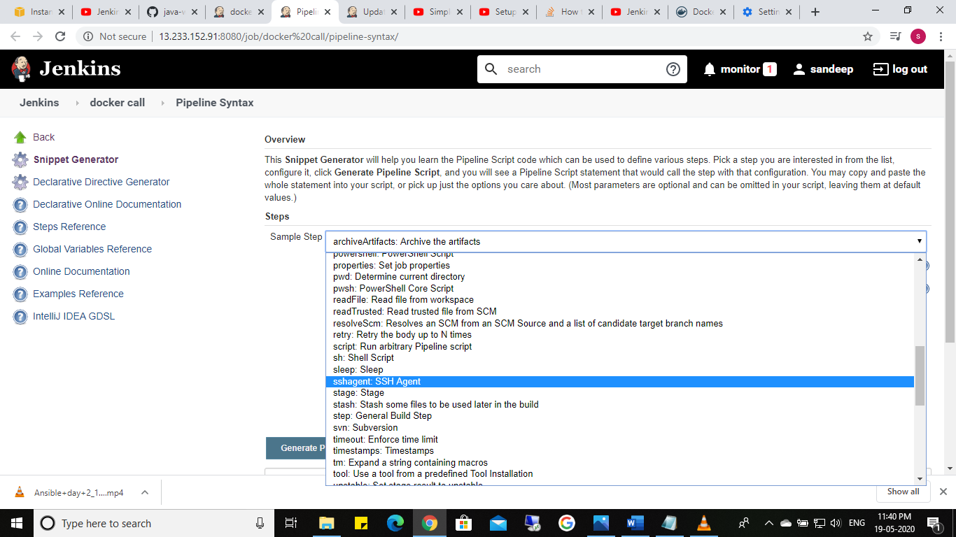

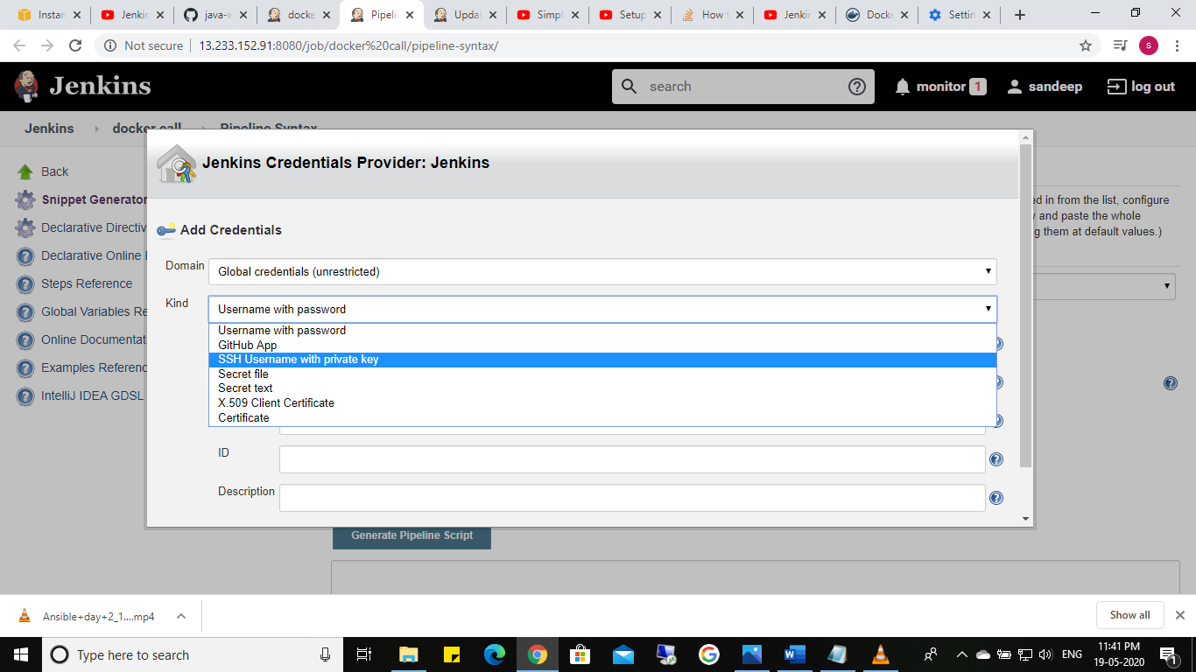

Add user name and .pem file

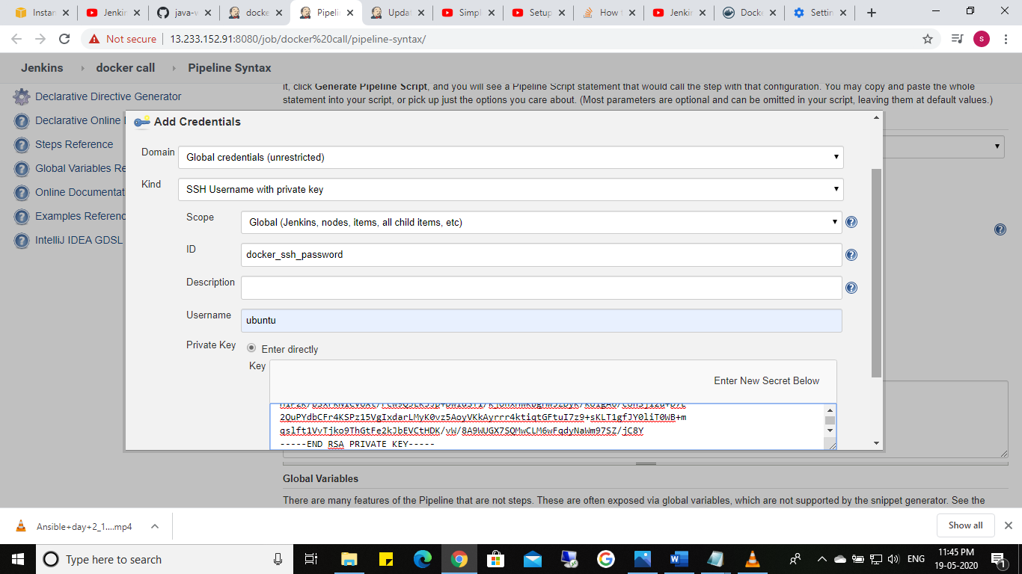

**Click generate pipeline script and copy the script**

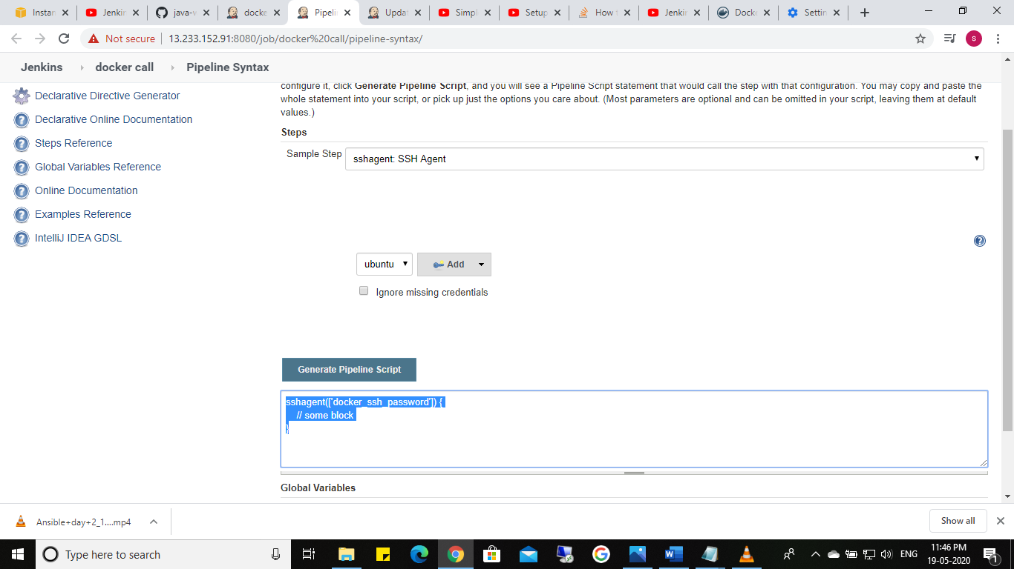

1. Run docker container from docker repository with pot number 8080
2. 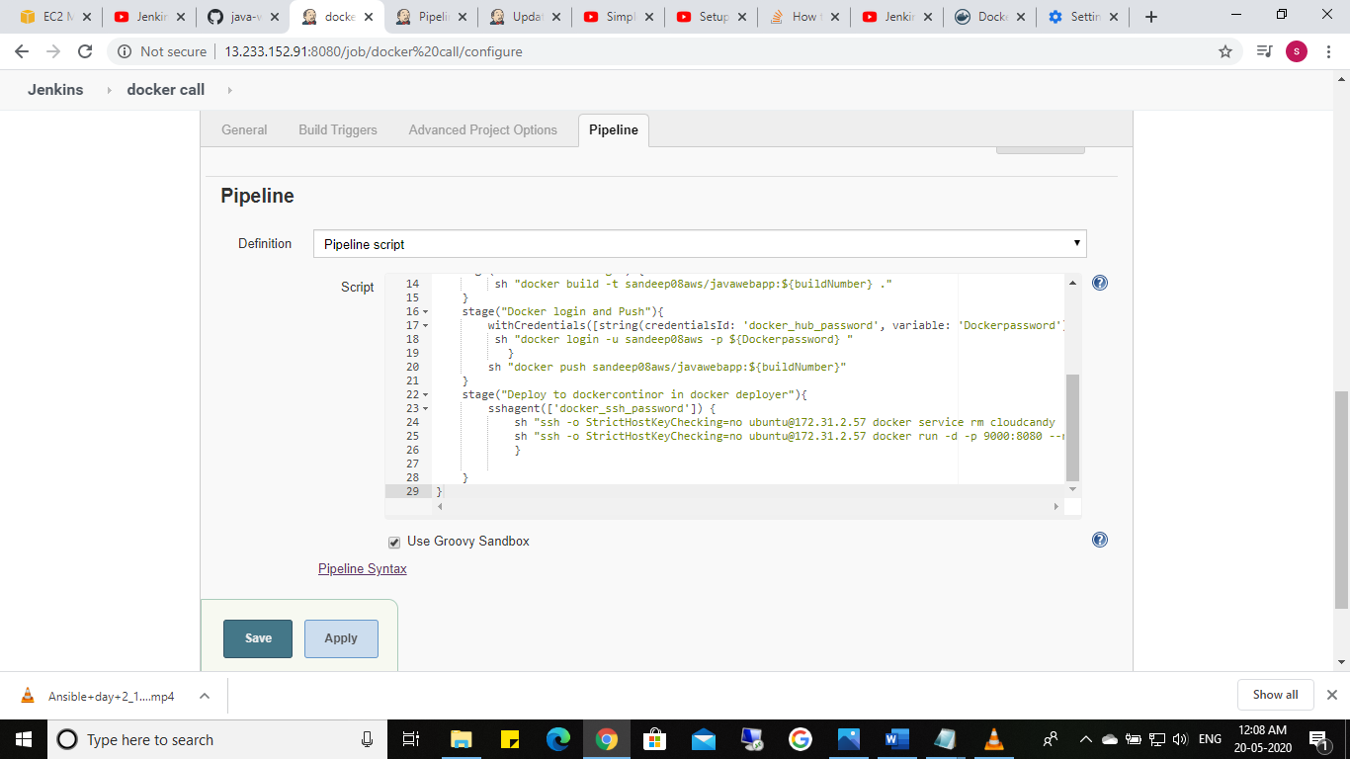

Build the script to run container:

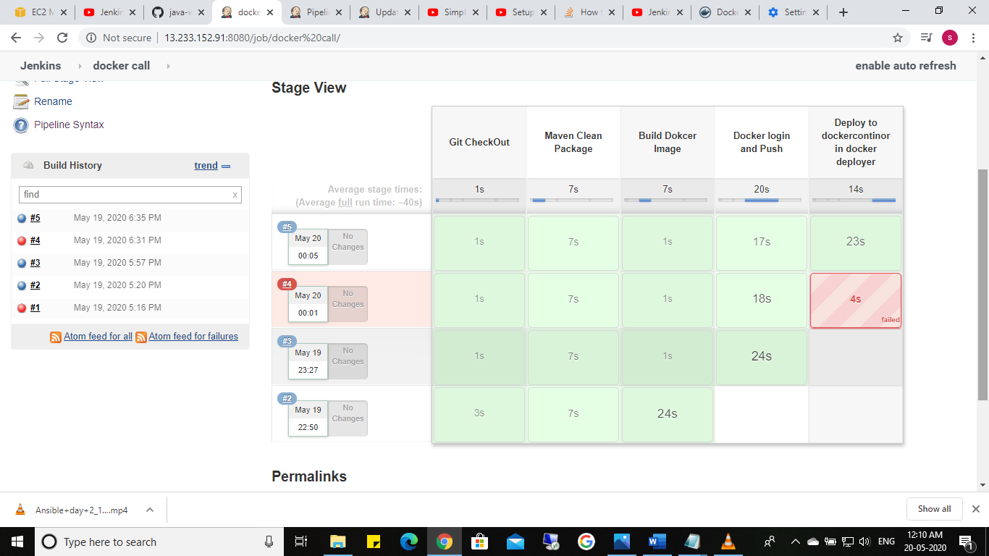

Check the with <deployer public ip >:8080:

<http://13.126.56.81:8080/java-web-app/>

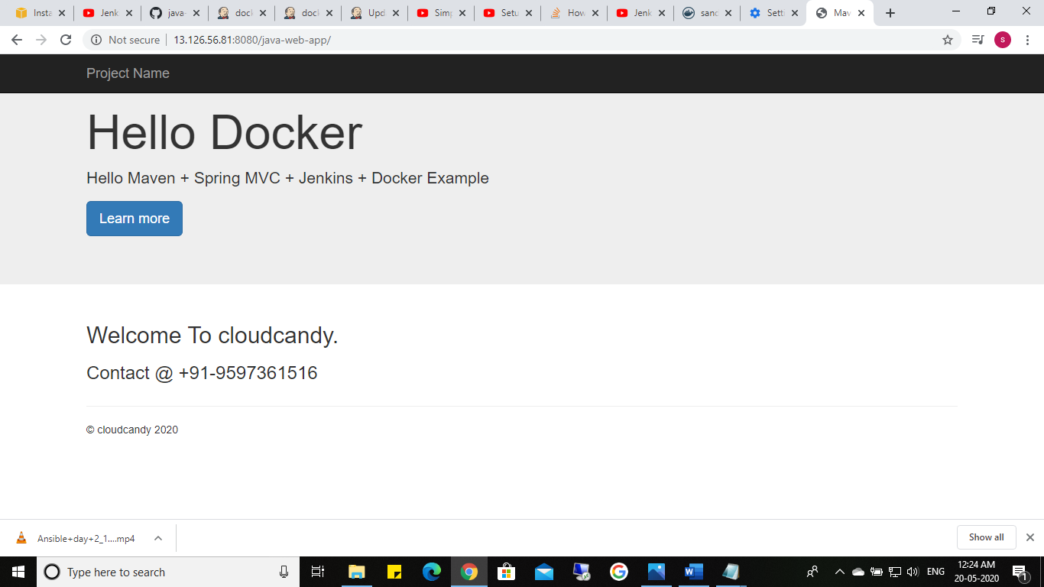

project Script:

node

{

def buildNumber = BUILD_NUMBER

stage("Git CheckOut"){

git url: 'https://github.com/sandeepdurai/java-web-app-docker.git',branch: 'master'

}

stage(" Maven Clean Package"){

def mavenHome = tool name: "Maven", type: "maven"

def mavenCMD = "${mavenHome}/bin/mvn"

sh "${mavenCMD} clean package"

}

stage("Build Dokcer Image") {

sh "docker build -t sandeep08aws/javawebapp:${buildNumber} ."

}

stage("Docker login and Push"){

withCredentials([string(credentialsId: 'docker_hub_password', variable: 'Dockerpassword')]){

sh "docker login -u sandeep08aws -p ${Dockerpassword} "

}

sh "docker push sandeep08aws/javawebapp:${buildNumber}"

}

stage("Deploy to dockercontinor in docker deployer"){

sshagent(['docker_ssh_password']) {

sh "ssh -o StrictHostKeyChecking=no ubuntu@172.31.2.57 docker rm -f cloudcandy || true"

sh "ssh -o StrictHostKeyChecking=no ubuntu@172.31.2.57 docker run -d -p 8080:8080 --name cloudcandy sandeep08aws/javawebapp:${buildNumber}"

}

}